Need to registor the below repo as mentioned file

/etc/regionserverclnt.cfg

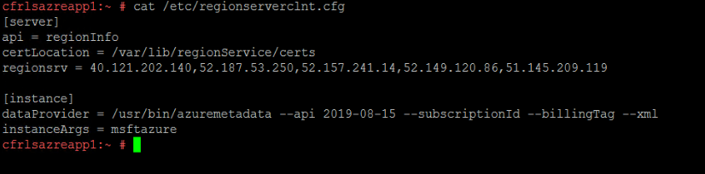

Region server IP

52.233.155.246/32 (need port 443 - region server)

40.121.202.140/32 (need port 443 - region server)

52.187.53.250/32 ( need port 443 - region server)

52.157.241.14 (need port 80/443 - RMT server)

52.149.120.86 (need port 80/443 - RMT server)

51.145.209.119 (need port 80/443 - RMT server)

Regis certify : wget --no-check-certificate  <https://52.188.224.179/late_instance_offline_update_azure_SLE12.tar.gz>

Then execute unzip command

tar -xf late_instance_offline_update_azure_SLE12.tar.gz

then cd x86_64

zypper --no-refresh --no-remote --non-interactive in *.rpm

then register new repo

/usr/sbin/registercloudguest --force-new

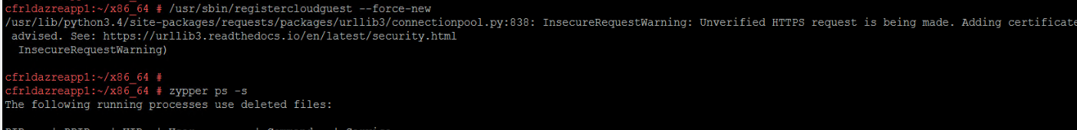

Command : zypper ps -s

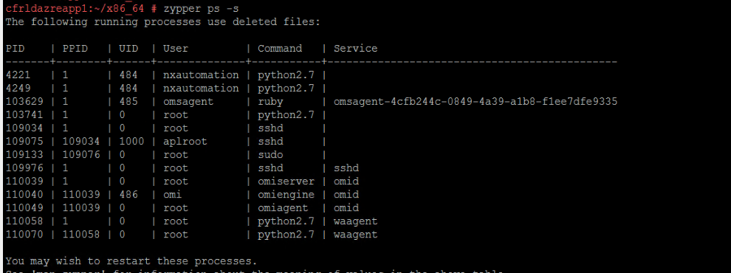

Above snip we need to restart the services used below command

systemctl restart sshd

systemctl restart omid

systemctl restart waagent

/opt/microsoft/omsagent/bin/service_control restart ( #To restart OMI service)

Once done we can ensure the current active services

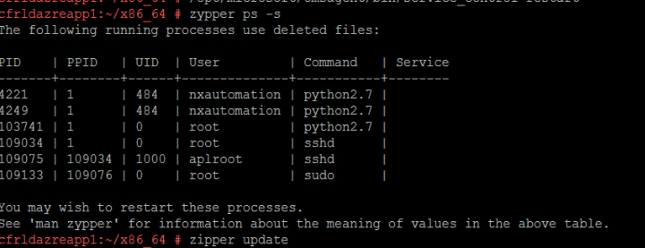

Then zypper update

If received any errors called “System management is locked by the application” Then kill the respected process ID

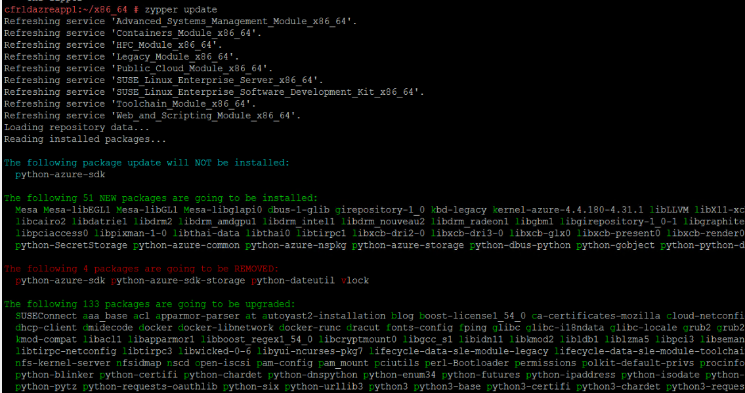

Once update done, we need to reboot the server.

Then execute the command to migrate the OS

zypper migration

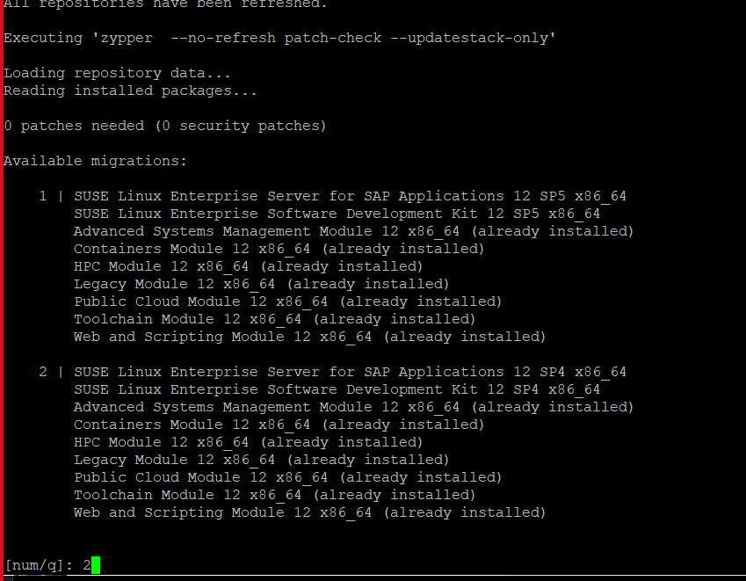

All servers are running sp3, hence first we should update SP4 after that we can update sp5

License acceptance.

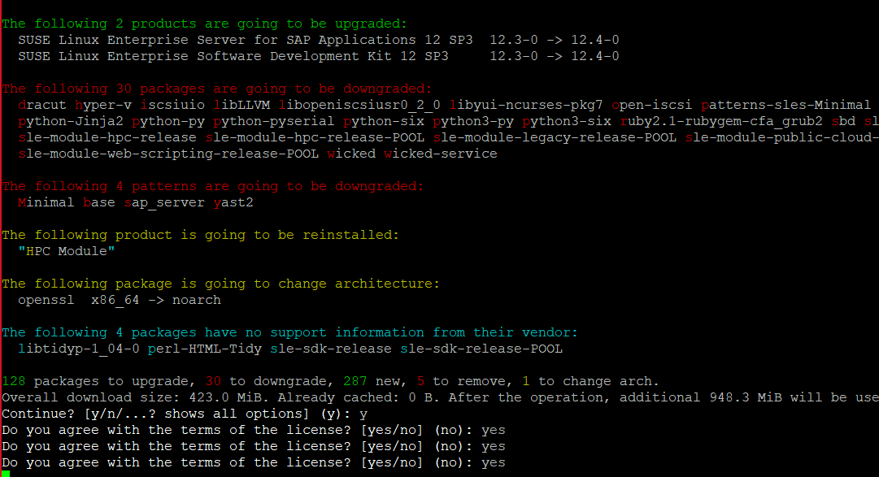

Once done, we need to verify the OS version

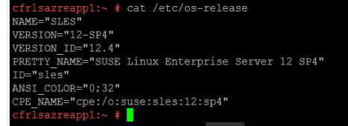

Then we need to update the OS zypper update -🡪 reboot 🡪 then install the SP5🡪update OS zypper update

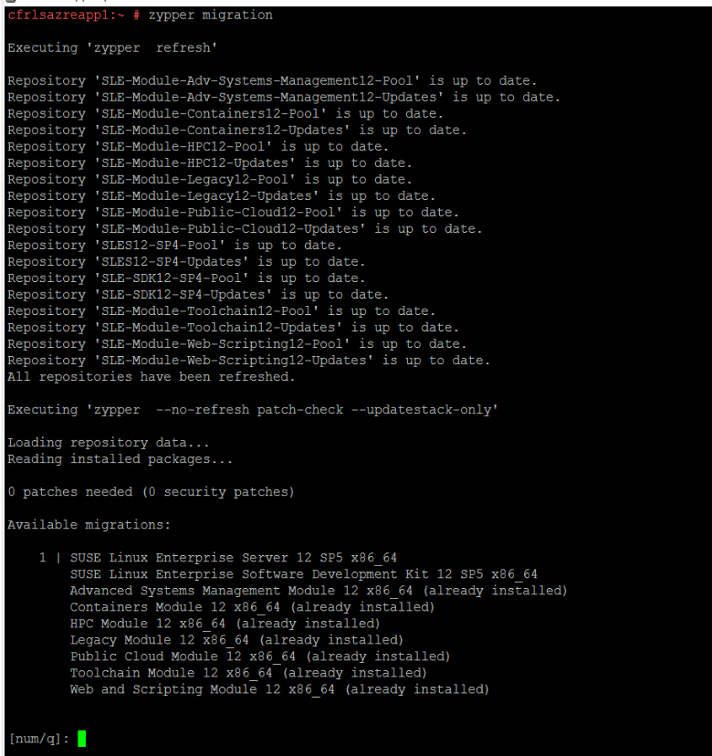

then we need to remove the old kernel

To list all kernel zypper se -si 'kernel*'

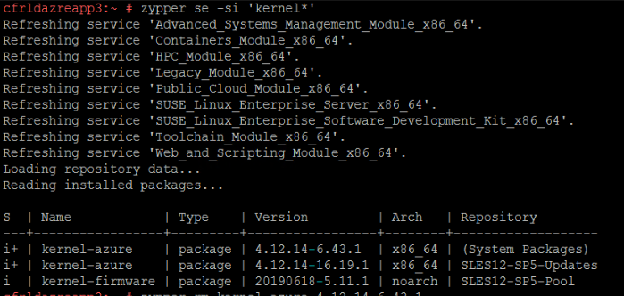

Remove command : zypper rm kernel-azure-4.12.14-6.43.1

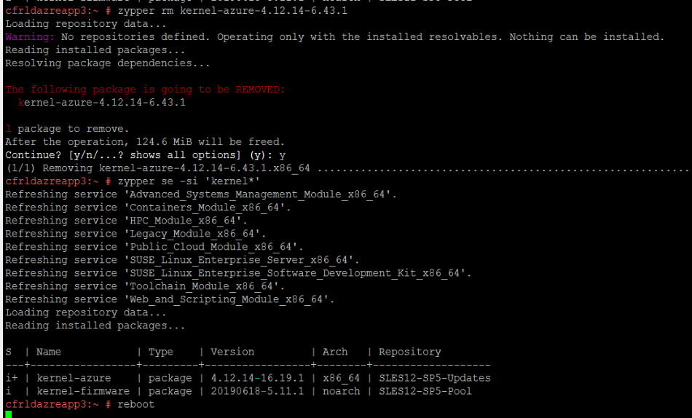

Then reboot the server

To check Samba

zypper se --installed-only | grep samba

rpm -qa samba-client

zypper remove samba-client

rpm -qa samba-libs

zypper remove samba-libs